DIS-INDO-Dayak-Female guardian

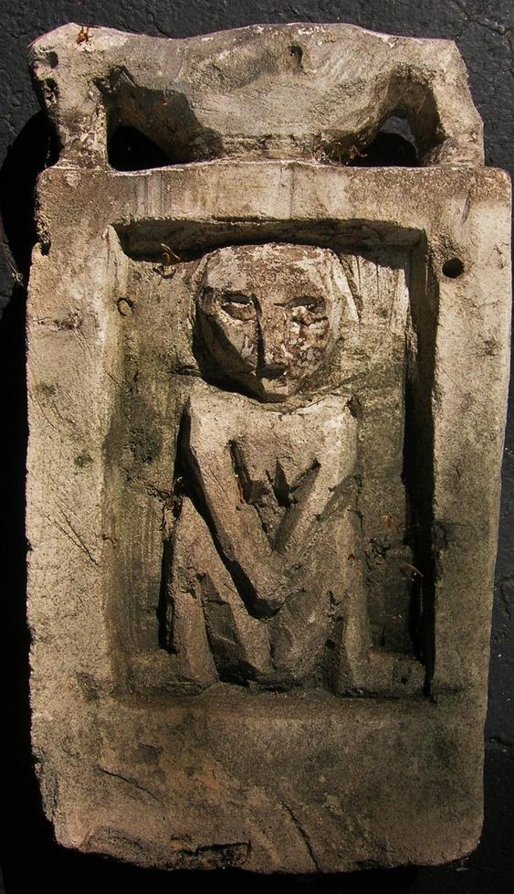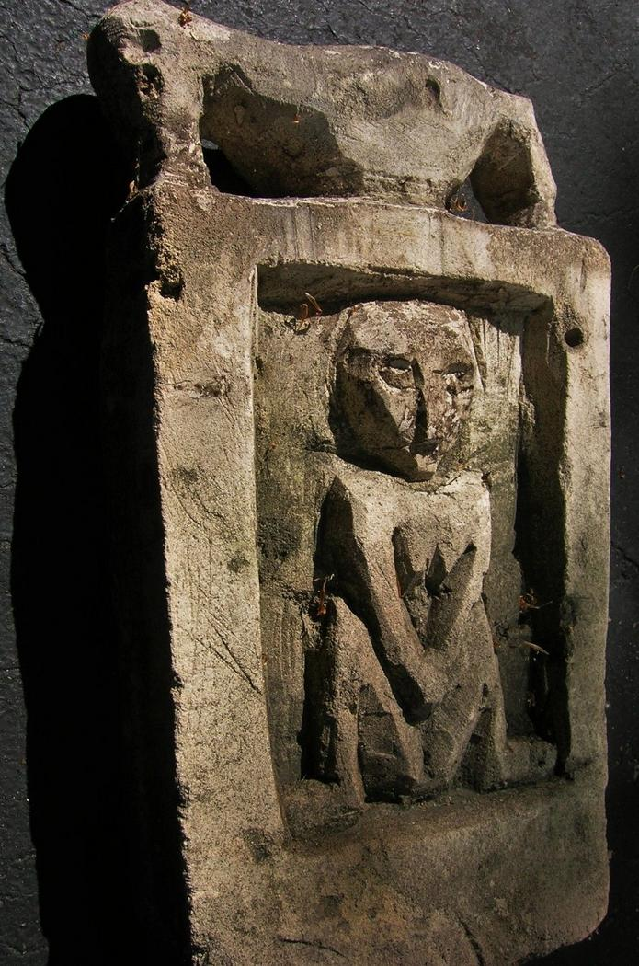

Dayak stone apotropaic figure, 15 inches tall, ca. 1910. Ex Bourke Estate, New York City, 2014.

This figure shows a female guardian of the menses hut for girls entering womanhood. The bird above indicated a symbol of fertility.

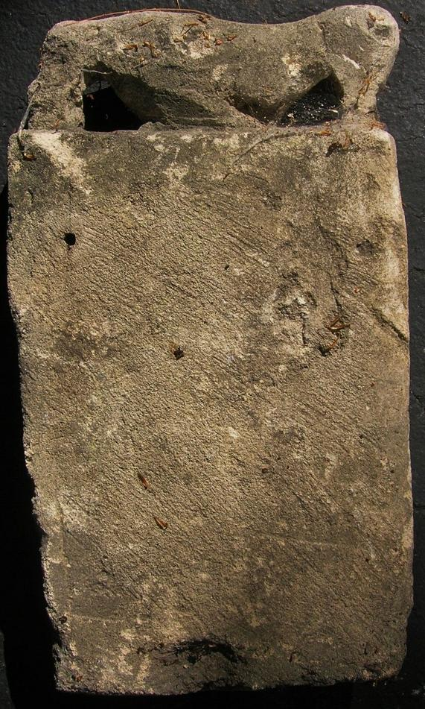

This plaque would have been fastened on the hut through the attachment holes shown on the reverse.

Sold by [primitifstuff](http://myworld.ebay.com/primitifstuff) ( [1787](http://feedback.ebay.com/ws/eBayISAPI.dll?ViewFeedback&userid=primitifstuff) )

### Delivery package 1 of 1

Estimated delivery Friday, Oct 9, 2015 - Tuesday, Oct 13, 2015

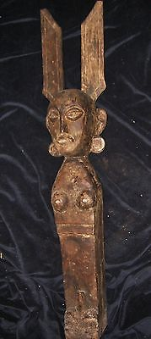

#### [NIAS UMA FIGURE 35"](http://www.ebay.com/itm/221898123140)

|  |  |
| --- | --- |
| Item price | $89.99 |
| Quantity | 1 |
| Item number | 221898123140 |
| Shipping service | USPS Priority Mail |

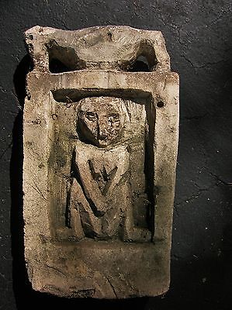

#### [DAYAK STONE PROTECTIVE FIGURE 15"](http://www.ebay.com/itm/221898141111)

|  |  |
| --- | --- |
| Item price | $79.99 |
| Quantity | 1 |
| Item number | 221898141111 |
| Shipping service | USPS Priority Mail |